1) Create one IAM user and assign ec2,s3 full access role.

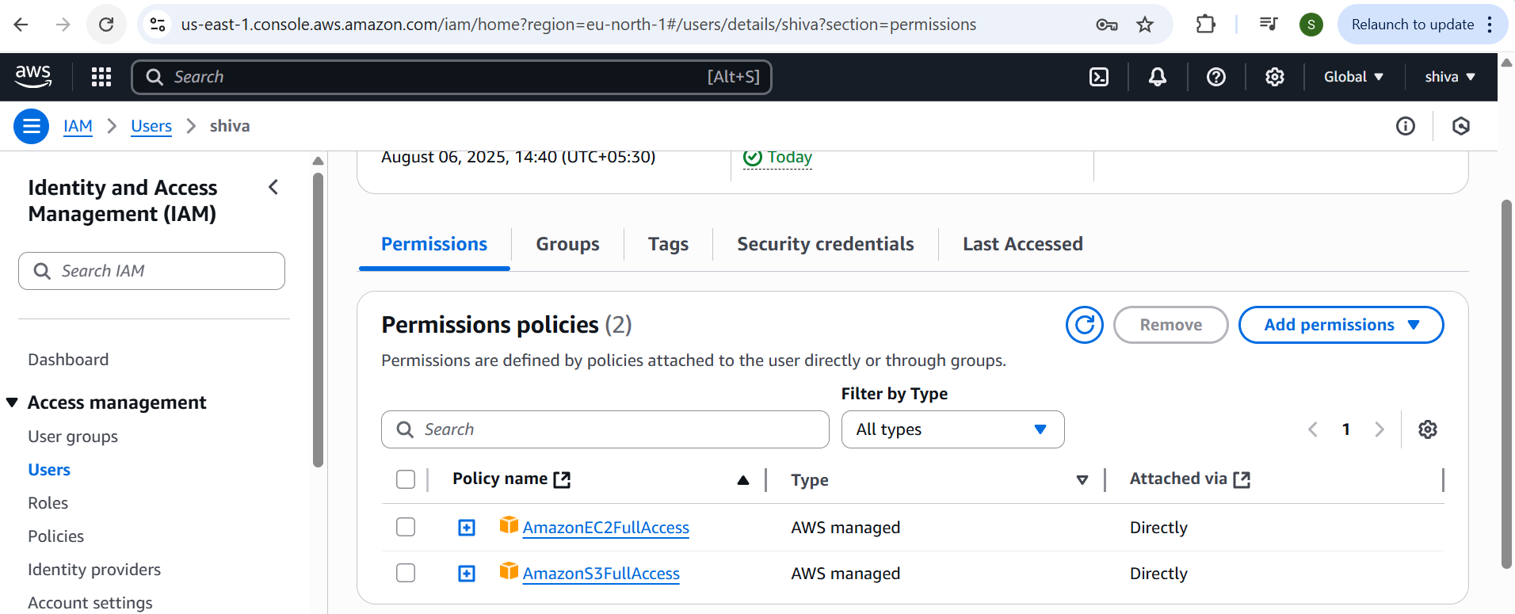

2) Create one Group in IAM and Assign Read access for ec2.

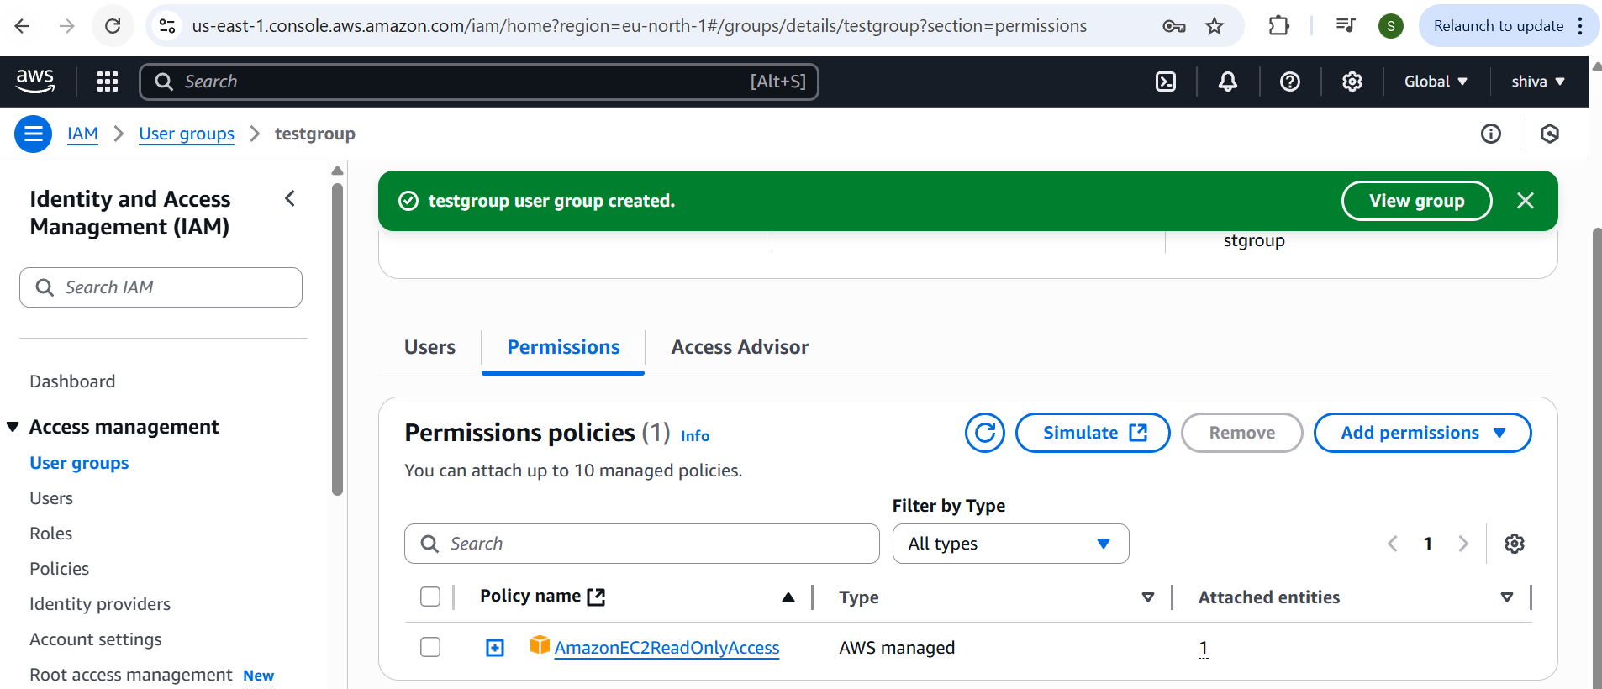

3) Create a new user with name Devops and add to the group created in task2.

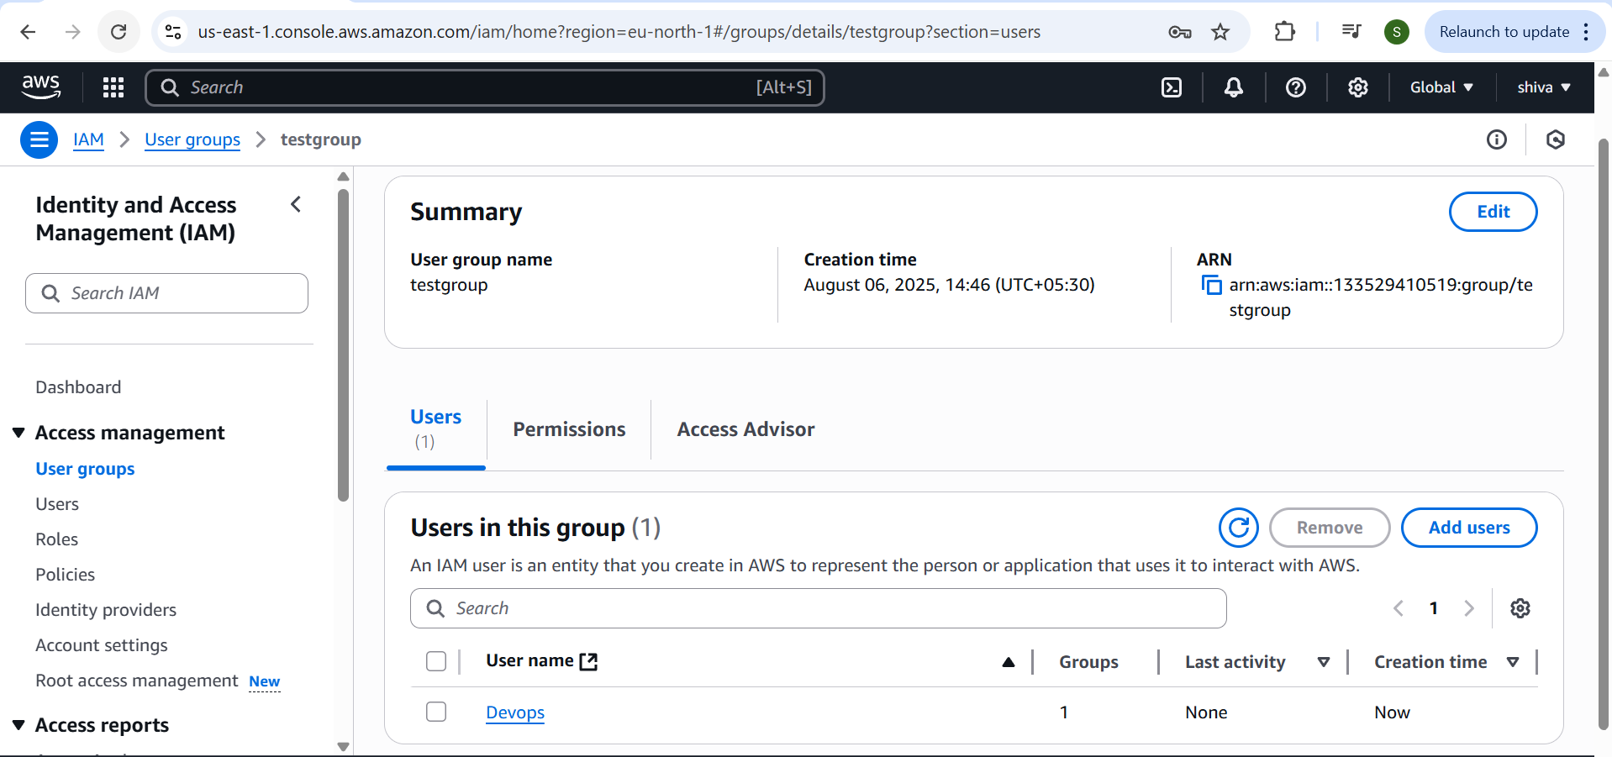

4) Write a bash script to create a IAM user with VPC full access.

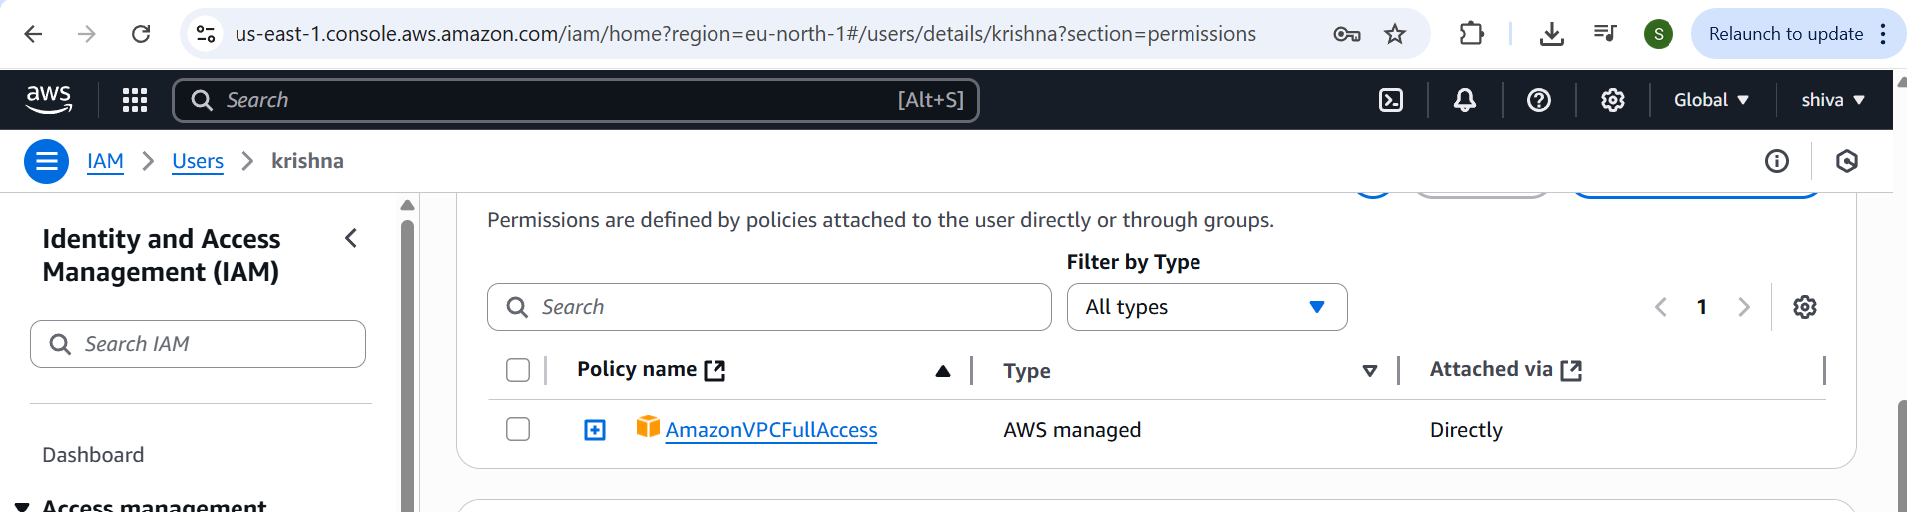

5) Create a IAM policy to access ec2 for a specific user in specific regions only.

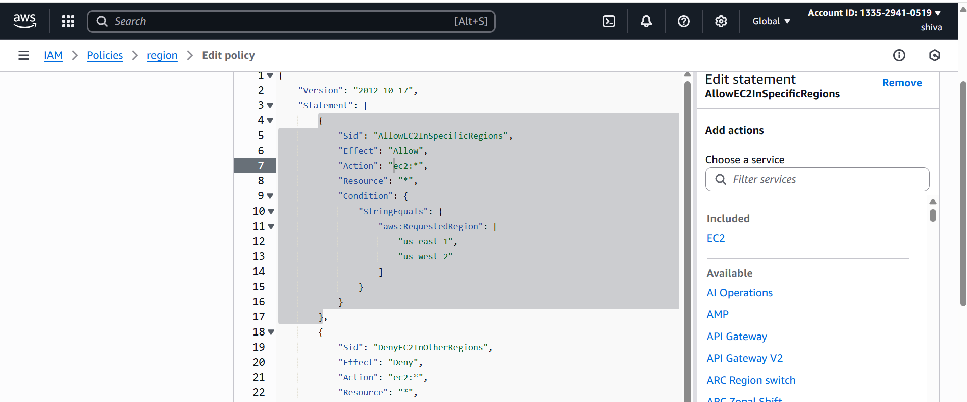

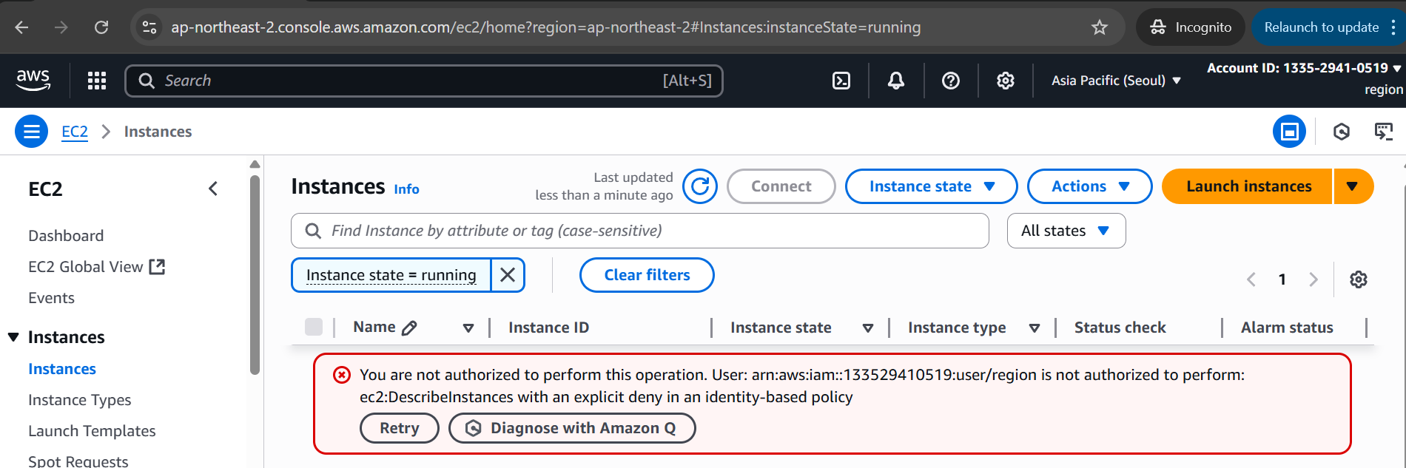

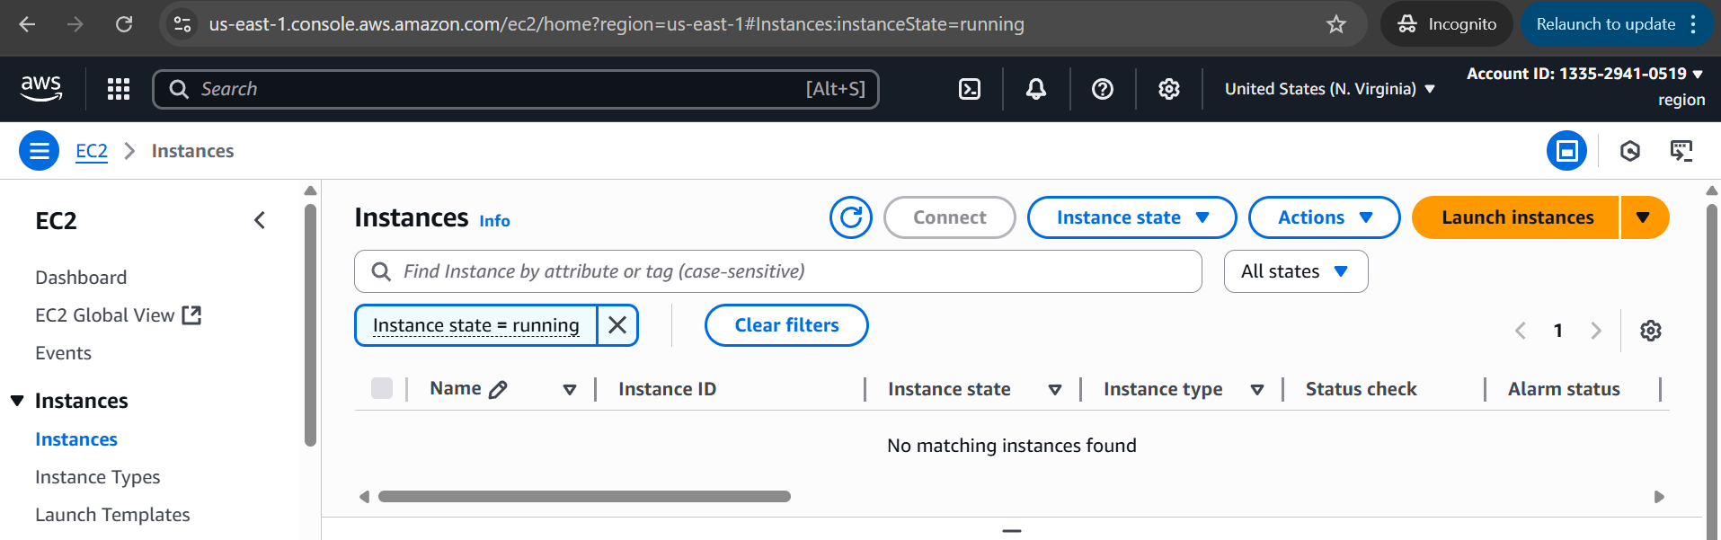

6) We have two accounts Account A and Account B, Account A user should access s3 bucket in Account B. (Collaborate with team member and execute this.Mostly asked in every interview)

